Algebra 2 TEST 6.2 Review DO ON OWN PAPER!

I. CIRCLES.

|  |
| --- |
| 1. Find the center and radius of the circle . Then graph. |
| 2. Write the equation of the circle with center  and radius . |
| 3. Write the equation of the circle translated down 4 and right 6 from the circle . |
| 4. Write the equation of the circle with center  and tangent to the -axis. |
| 5. Write the equation of the circle with center  and passing through the point . |

II. ELLIPSES.

|  |  |  |  |
| --- | --- | --- | --- |
| For #6-8, rewrite the equation in standard form (if necessary). Find the center, vertices, co-vertices, and foci of each ellipse. Then graph.   |  |  |  | | --- | --- | --- | | 6. | 7. | 8. | |
| 9. What do , , and  each represent in an ellipse? |
| 10. State the relationship of , , and f in an ellipse. |
| 11. Write the equation of the ellipse with center , co-vertices  and foci |
| 12. Write the equation of the ellipse with center , vertices  and foci . |

III. HYPERBOLAS.

|  |  |  |  |
| --- | --- | --- | --- |
| For #13-15, rewrite the equation in standard form (if necessary). Find the center, vertices, co-vertices, and foci of each ellipse. Then graph.   |  |  |  | | --- | --- | --- | | 13. | 14. | 15. | |
| 16. What do , , and f each represent in a hyperbola? |
| 17. State the relationship of , , and f in a hyperbola. |
| 18. Write the equation of the hyperbola with center , co-vertices  and foci |
| 19. Write the equation of the hyperbola with center , a vertex , and a focus . |

IV. For each graph, write its equation in standard form.

|  |  |  |
| --- | --- | --- |
| 20. | 21. | 22. |

**Answers: Graphs are @ the bottom...**

1. center  and radius  2.  3. 

4.  5. 

6. center ; vertices ; co-vertices ; foci  or 

7. center ; vertices  & ; co-vertices  & ; foci  & 

8. center ; vertices ; co-vertices  & ; foci  or 

9. distance from center to a vertex; distance from center to a co-vertex; f=distance from center to a focus

10. f2 = a2 - b2 11.  12. 

13. center ; vertices ; co-vertices ; foci  or ; asymptotes 

14. center ; vertices  & ; co-vertices  & ; foci  & ; asymptotes  or 

15. center ; vertices  & ; co-vertices ; foci  & ; asymptotes 

16. distance from center to a vertex; distance from center to a co-vertex; f=distance from center to a focus

17. f2 = a2 + b2 18.  19. 

20.  21.  22.

**Graphs:**

1. 6. 7. 8. 13.

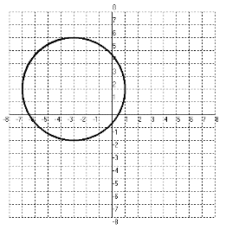 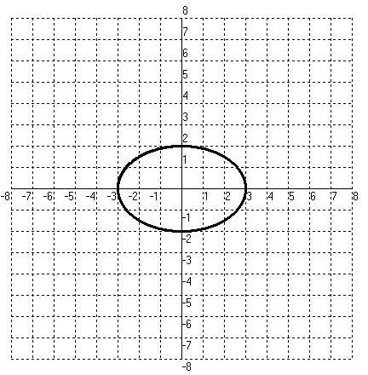 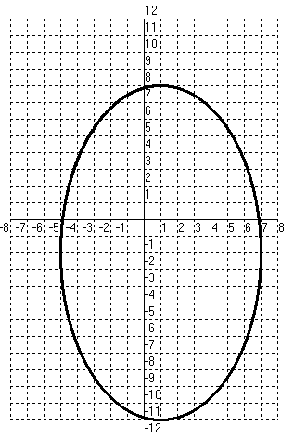 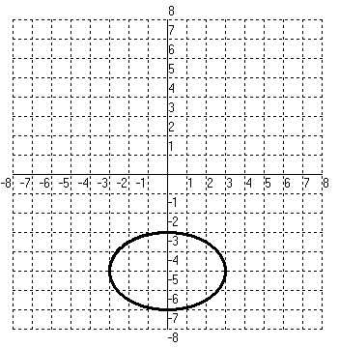 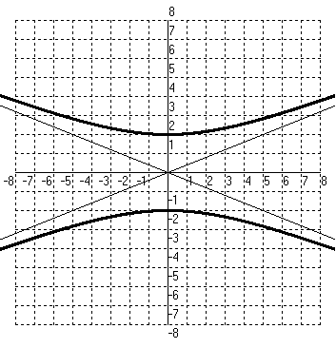

14. 15.

