**Algebra II 6th six weeks test Review**  Name:___________________________

**Identify the conic section**

1.  2.  3.  4. 

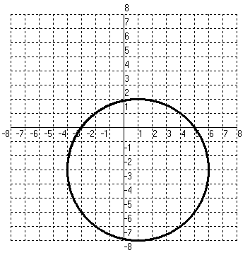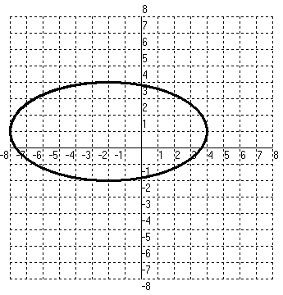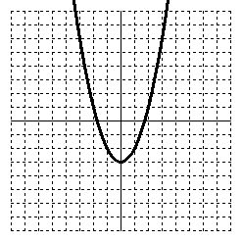**State the Domain and Range.**

5. 6. 8.

**Answer all information about the parabolas and graph: Direction it opens, vertex, focus, Directrix, axis of symmetry, and graph**

9. 10.  11. 



**Write the equation of the parabolas given the following parts**:

12. With vertex  and directrix  13. With focus and directrix .



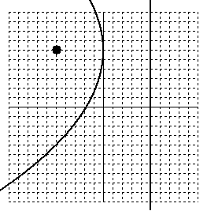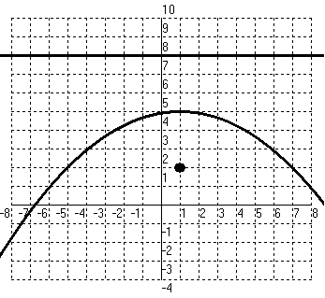14. 15.

**Use f(x), g(x), h(x) and k(x) to evaluate:**

|  |  |  |  |  |  |  |
| --- | --- | --- | --- | --- | --- | --- |
|  | -3 | -2 | -1 | 0 | 1 | 2 |
|  | -5 | -2 | 1 | 4 | 7 | 10 |

|  |  |  |  |  |  |  |
| --- | --- | --- | --- | --- | --- | --- |
|  | -2 | -1 | 0 | 1 | 2 | 3 |
|  | -3 | 0 | 1 | 0 | -3 | -8 |

 

16.  17.  18.  19.  20. 

**Answer the following questions about Circles**:

26. Find the center of the circle and the radius: 

27. Find the equation of the circle with center  and tangent to the -axis.

28. Find the equation of the circle with center  and point on the circle.

29. . Rewrite  in standard and find the center and the radius.

**Answer the following questions about ellipses**:

30 . Find the center of the ellipse: 

31. Find the vertices, co-vertices and Foci of the ellipse: 

32. Find the equation of the ellipse given co-vertices at with foci at 

33. Graph the ellipse . Include the foci.

**Answer the following questions about hyperbolas:**

34. Find the vertices, co-vertices and Foci of the hyperbola:



35. Find the asymptotes of the hyperbola: 

36. Write an equation of a hyperbola given center at (0,0), vertex at (0,4) and foci at (0,5)

37. Graph the hyperbola . Include the foci and asymptotes.



**REMEMBER TO BRING GRAPH PAPER TO THE TEST IF YOU THINK YOU MIGHT NEED IT!**

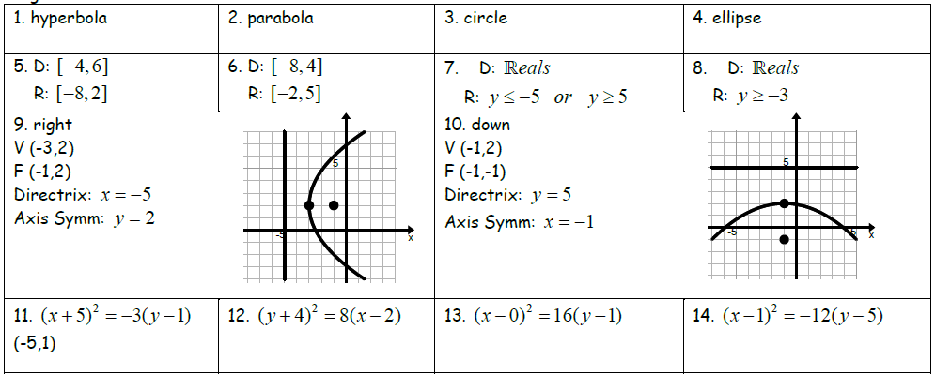

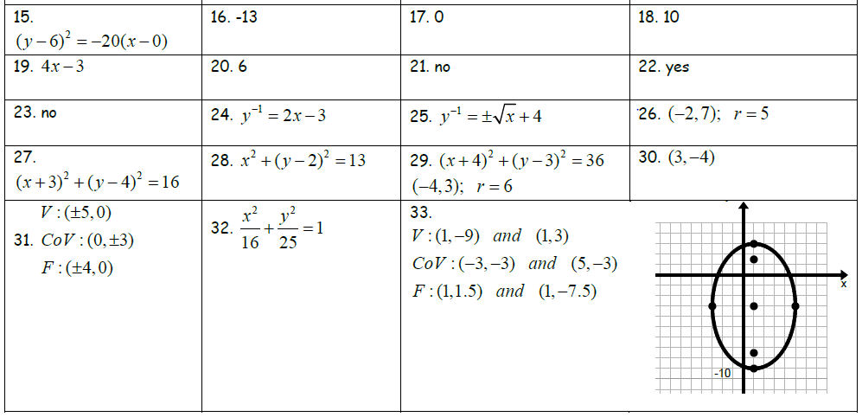

|  |  |  |
| --- | --- | --- |
| 34) Vertices: ( 4, 0) and (-4, 0)  Co – Vertices: (0, 3) and (0, -3)  Focus: (5, 0) and (-5, 0) | 35) $y=±\frac{2}{3}x$ | 36) $\frac{y^{2}}{16}-\frac{x^{2}}{9}=1$ |

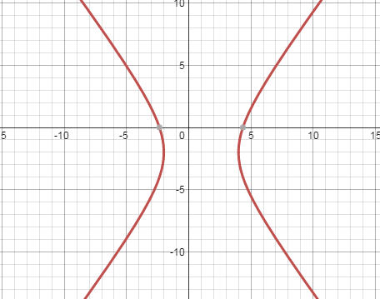37) Asymptotes: $y=±\frac{4}{3}\left(x-1\right)-2$

Foci: (5, -2) and (-2, -2)