Algebra 2 HW #1
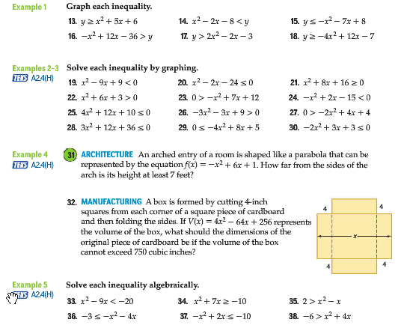
Page 287 # 16 – 21, 33 – 35

