NAME:_____________________________________________ Period: ____________
HW #4 STAAR/EOC Practice for Pre-AP Algebra I
- What is the range of the function shown on the graph below?
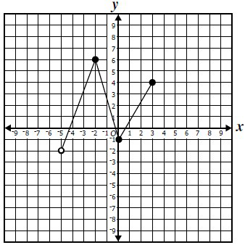
  - –5 < y ≤ 3
  - –2 ≤ y ≤ 3
  - –2 < y ≤ 6
  - –1 ≤ y ≤ 4

- A snow cone vendor made a table showing the relationship between the daily high temperature and the number of snow cones sold per day. What is the dependent quantity in this relationship?
  - The daily high temperature
  - The number of snow cones sold per day
  - All of the data in the table
  - Cannot be determined

- A car rental company charges a daily rate of $40 to rent a car. The company also charges an additional $.05 per mile after the first 100 miles. Carmen plans to rent a car from the company and take a 7­day trip from Texas to Florida and back. Which of these describes T, the total charges for Carmen to rent the car and drive m miles?
A. T = 40(7) + 0.05(100 – m)
B. T = 40(7) + 0.05(m – 100)
C. T = 0.05(7) + 40(100 – m)
D. T = 0.05(7) + 40(m – 100)

The function, p = 2s + 3.50, represents the relationship between the cost, p, of a pair of pants and the cost, s, of a shirt, not including tax. Which statement is the best interpretation of this information?

  - The cost of a shirt is $3.50 more than twice the cost of a pair of pants.
B. The cost of a shirt is $3 .50 more than half the cost of a pair of pants.
c. The cost of a pair of pants is $3.50 more than twice the cost of a shirt.
D. The cost of a pair of pants is $3.50 more than half the cost of a shirt.
- Which expression can be used to find the values of S(n) in the table below?
n | 1 | 2 | 3 | 4 | 5 | 6
S(n) | 8 | 13 | 18 | 23 | ? | ?

  - 4n + 4
  - 3n + 5
  - n + 7
  - 5n + 3

- Students in a group of chess teams collected data about hours of team practice and the number of matches the team won. The graph shows the results of the data.
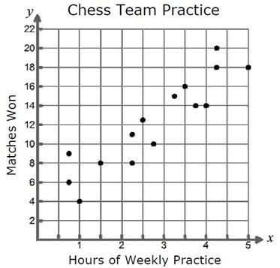
Which best describes the relationship shown on the graph?
  - Negative trend
  - Constant t trend
  - Positive trend
  - No trend

- The function table below shows the values f(n) for given values of n.
n | 1 | 2 | 3 | 4
f(n) | 3 | 3.5 | 4 | 4.5

Which function best represents the relationship between the quantities in the table?
A. 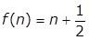
B.
C. 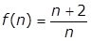
D. 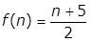

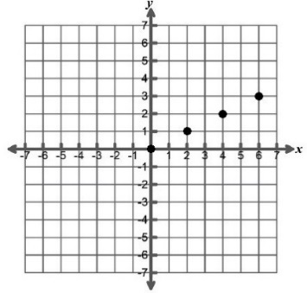
- The relationship given by the ordered pairs {(0, 0), (2, 1), (4, 2), (6, 3)} can be represented in several other ways. Which of the following is not a correct representation?

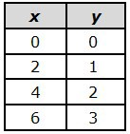
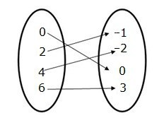
- x-2y=0 and B C. D.
the domain is
{0, 2, 4, 6}

9. The maximum height and speed of various roller coasters in North America are shown in the table below.
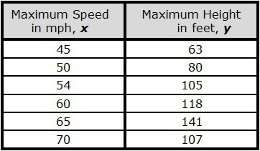
Which of the following accurately represents the domain of this set of data?
A. 45 ≤ x ≤ 70 B 63 ≤ y ≤ 107 C. {45, 50, 54, 60, 65, 70} D.{63, 80, 105, 118, 141, 107}

10. A math class was given 90 minutes to complete a test. The scatterplot below shows the relationship between the speed at which the students completed the test and the number of careless mistakes they made.
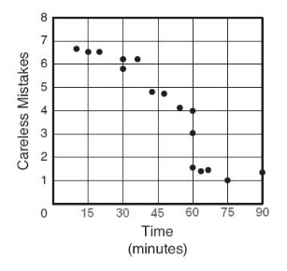
Which of the following describes the correlation between the number of minutes spent on the test and the number of careless mistakes made?

  - Constant correlation C. Negative correlation
  - No correlation D. Positive correlation

11.Which mapping best represents the function f(x) = 3x2 – 4 when the replacement set for x is {­1, 0, 4}?
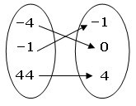
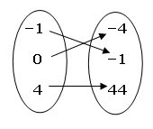
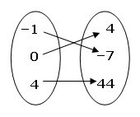
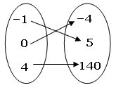
- B. C. D.

