Algebra 2 TEST 1.1 Review DO ON OWN PAPER!

I. Simplify NO WORK…NO CREDIT!

|  |  |  |  |
| --- | --- | --- | --- |
| 1.  12÷2∙3+7 | 2  2∙9÷2∙3-1 | 3. | |
| Use the graph to match the lines  with the given information.  Which line has:  4. a y-intercept of 2?  5. an x-intercept of 2?  6. a slope of  7. a slope of –2?  9. a slope of 1? | | |

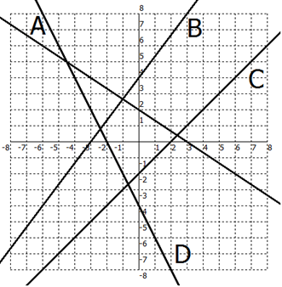

II. Write the following in interval notation.

|  |  |
| --- | --- |
| 10. | 11. |
| 12. | 13. |

III Write the following as an inequality in set notation.

|  |  |
| --- | --- |
| 14. | 15. |

IV. Simplify.

|  |  |  |
| --- | --- | --- |
| 16. | 17. | 18. |

V. Evaluate when  and .

|  |  |  |
| --- | --- | --- |
| 19. | 20. | 21. |

VII. WORD PROBLEM.

|  |
| --- |
| 23.Write an algebraic expression for the mileage cost of renting a U-HAUL if there is a flat rate of $75 and $0.57 per mile.   1. How much would it cost to go 200 miles? |

VIII Are the following functions? Why or why not?

|  |  |  |  |  |  |  |  |  |  |  |  |  |  |  |  |
| --- | --- | --- | --- | --- | --- | --- | --- | --- | --- | --- | --- | --- | --- | --- | --- |
| 24. | 25. | 26.   |  |  |  |  |  |  | | --- | --- | --- | --- | --- | --- | |  |  |  |  |  |  | |  |  |  |  |  |  | | 27. |

IX. State the domain and range for each graph in interval notation.

|  |  |
| --- | --- |
| 28. | 29. |

X. Evaluate each function at the given value:

|  |  |  |
| --- | --- | --- |
| 30.  Find  and . | 31.  Find  and . | 32. Given the graph, find , , and . |

XI. Another WORD PROBLEM.

|  |
| --- |
| 33. An electrician charges a service charge of $60 plus $35 an hour. Write a function to model what he charges. What would he make if he worked 3 hours? |

Graph each:

|  |  |
| --- | --- |
| 34. | 35. a line with a slope of 3 through (-3,1) |

Determine if the data represents a linear function.

|  |  |  |  |  |  |  |  |  |  |  |  |  |  |  |  |  |  |  |  |  |  |
| --- | --- | --- | --- | --- | --- | --- | --- | --- | --- | --- | --- | --- | --- | --- | --- | --- | --- | --- | --- | --- | --- |
| 36.   |  |  |  |  |  | | --- | --- | --- | --- | --- | | x | -2 | -1 | 0 | 1 | | Y | 11 | 8 | 5 | 2 | | 37.   |  |  |  |  |  | | --- | --- | --- | --- | --- | | x | -2 | -1 | 0 | 1 | | Y | 8 | 12 | 17 | 23 | |

Solve the following.

|  |  |  |
| --- | --- | --- |
| 38. a – 8 = 23 | 39. 2(3x + 8) = 10 | 40. 5b – 17 = b +7 |
| 41. 3(y – 2) – 3(2y – 1) = 32 | 42. $\frac{7}{4}=\frac{c-5}{3}$ | 43. 6(x + 3) ≥ 42 |