Algebra 2 Name ________________________________ Date ________
HW #9 Absolute Value Transformations

If $f\left(x\right)=\left|x\right|$ was transformed, what would the equation change to if:
- the graph moved down 2 units? | - the graph moved 1 unit to the right? | - the graph moved 4 units to the left?
- the graph had a vertex of (8, ½) ? | - the graph had a vertex of (1.5, 4.5)? | - the graph had a vertex of (-2.5, 3)

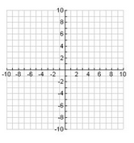
Graph each transformation WITHOUT A CALCULATOR
- Reflect $f\left(x\right)=\left|x-5\right|+2$ across the x – axis and write the new function below | - $g\left(x\right)=\left|x-6\right|$ | - $p\left(x\right)=2\left|x-1\right|$
Write the equation for each graph below.
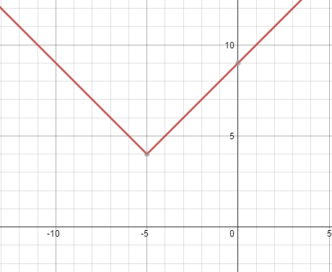  10) | 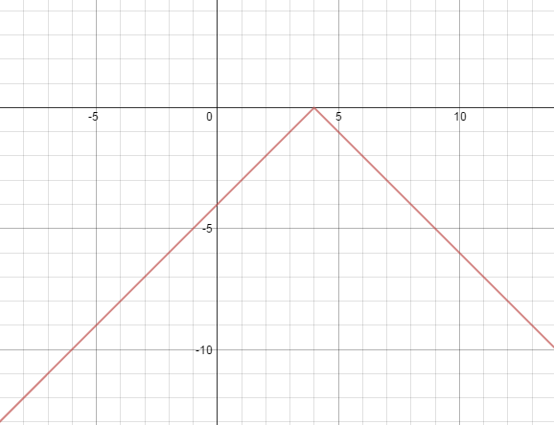  11)

