Name _______________________________________________ Date ________________ Period _______

HW Introduction to Linear Programming (Graphing Constraints)

Graph each system of inequalities and identify the vertices of the solution region.

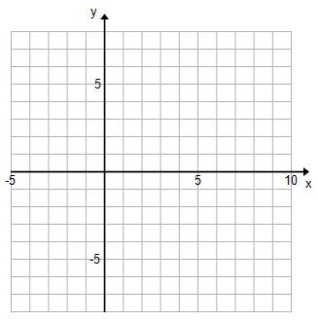

Example:



|  |  |
| --- | --- |
| 1) | 2) |
| 3) | 4) |
| 5) | 6) |
| 7) | |