Introduction to Graphing Rational Functions
itutoring.com
Username: bowiehs
Password: bulldogs
Algebra 2 Chapter 10 Lesson 9: Graphing Rational Functions by Finding Asymptotes

How do you find…
Vertical Asymptote

Horizontal Asymptote

Zeros or x – intercepts

y – intercept

Examples:
a) $y=\frac{3}{x-3}$  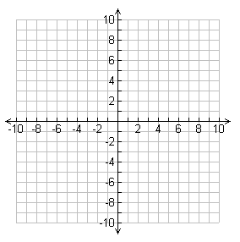 | b) $y=\frac{-4}{x+2}$
c) $y=\frac{x-1}{x}$ | d) $y=\frac{-x+3}{x-2}$
e) $y=\frac{2}{{(x-2)}^{2}}$ | f) $y=\frac{-1}{{(x+1)}^{2}}$

GLUE HERE

