Algebra 2 4th SIX WEEKS TEST Review DO ON OWN PAPER!

This review covers problems from TEST 4.1, TEST 4.2, and TEST 4.3. It would be wise to look over your graded tests in addition to completing this review.

I. State the degree of each polynomial.

|  |  |  |
| --- | --- | --- |
| 1. | 2. | 3. |

II. Add or subtract and write in standard form.

|  |  |
| --- | --- |
| 4. | 5. |

III. Find the product.

|  |  |  |
| --- | --- | --- |
| 6. | 7. | 8. |

IV. Use synthetic division to divide.

|  |
| --- |
| 9. |

V. Evaluate the remainder. Then decide if  is a factor of the polynomial.

|  |
| --- |
| 10. |

VI. Factor. (Methods to consider are factoring by grouping or the sum or difference of cubes.)

|  |  |
| --- | --- |
| 11. | 12. |

VII. Solve by factoring.

|  |  |
| --- | --- |
| 13. | 14. |

VIII. Write the polynomial with the following roots in standard form.

|  |
| --- |
| 15. |

IX. State the end behavior of each polynomial.

|  |  |  |
| --- | --- | --- |
| 16. | 17. | 18. |

X. Use the polynomial in #18 to complete the following problems.

|  |  |
| --- | --- |
| 19. Sketch the graph of the polynomial in #18. | 20. Which root has a multiplicity of 3 for problem #18? |

XI. State the possible rational roots for the following…

|  |  |
| --- | --- |
| 21. | 22. |

XII. Find all the ACTUAL zeros of the following polynomials.

|  |  |
| --- | --- |
| 23. | 24. |

XIII. State whether the equation models growth or decay. Then state the percent of increase or decrease.

|  |  |  |
| --- | --- | --- |
| 25. | 26. | 27. |

XIV. Word Problem.

|  |
| --- |
| 28. A $36,000 car depreciates at a rate of 9.5% per year. What will be the worth of the car in 6 years? When will the care be worth $10,000? |

XV. Rewrite in logarithmic form.

|  |  |  |
| --- | --- | --- |
| 29. | 30. | 31. |

XVI. Rewrite in exponential form.

|  |  |  |
| --- | --- | --- |
| 32. | 33. | 34. |

XVII. Write as a single logarithm. Then simplify.

|  |  |  |
| --- | --- | --- |
| 35. | 36. | 37. |

XVIII. Find the inverse function of the following. Then graph the function and its inverse function on the same graph.

|  |
| --- |
| 38. |

Answers: 1. 4 2. 8 3. 5 4.  5. 

6.  7.  8. 

9.  10. remainder = 194;  is NOT a factor of the polynomial

11.  12.  13.  14. 

15.  16. ,  AND , 

17. ,  AND ,  18. ,  AND , 

20. 1 21.  22. 

23.  24.  25. decay; 60% decrease 26. growth; 52% increase

27. growth; 33% increase 28. $19,778.53; 12.8 years 29.  30. 

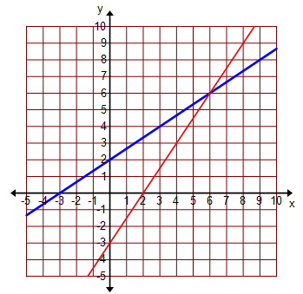31.  32.  33.  34.  35. 2 36. 1 37. 1.26

37. 38.  19.